Week 2 Homework – Big O Time Complexity
In this homework, the time complexity of 7 given algorithms is analyzed using Big O notation.

Algorithm 1
for (i = 1; i <= n; i++) print("Hello World");
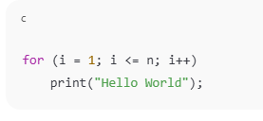
Time Complexity: O(n)

Algorithm 2
Nested loops from 1 to n.
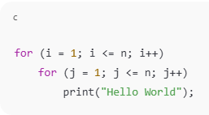
Time Complexity: O(n²)

Algorithm 3
i is multiplied by 2 each iteration.
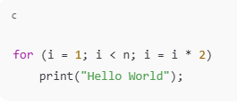
Time Complexity: O(log n)

Algorithm 4
i is divided by 5 each iteration.
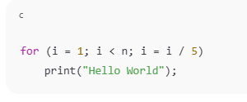
Time Complexity: O(log n)

Algorithm 5
i increases exponentially until n³.
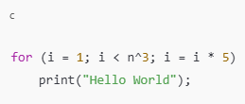
Time Complexity: O(log n)

Algorithm 6
Loop condition i² ≤ n.
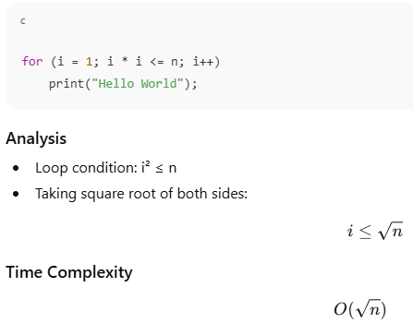
Time Complexity: O(√n)

Algorithm 7
k grows as arithmetic series.

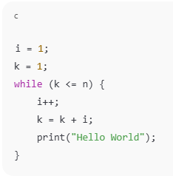
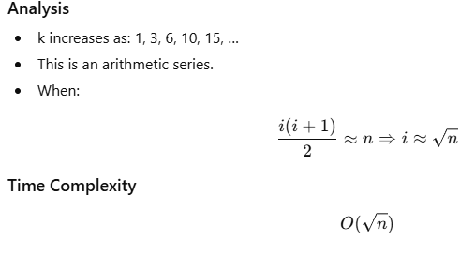
Time Complexity: O(√n)
